
UNDER EMBARGO UNTIL 00:01 BST TUESDAY 11TH JUNE 2024
The Power of Silence: iFi launches LAN iPurifier Pro under new SilentPower brand

Southport, UK – iFi Audio, a trailblazer in high-fidelity audio components, is proud to announce the launch of the LAN iPurifier Pro (£299, $299, $AUD299) as part of the new SilentPower brand. The revolutionary brand of power and signal solutions has been formed with the intention of delivering silence and pure clarity to audio systems across the globe. This allows audio connoisseurs to experience the best possible sound quality with no distortion or interference from the power supply or cables.
The SilentPower brand is categorised into four main segments: Power supplies, Cables, Conditioners and Accessories. Each segment is meticulously engineered to deliver superior noise cancellation and power purity, ensuring that every audio experience is pristine and immersive.
iFi’s mission with SilentPower is to unlock the final 10-30% of your audio system's potential by providing high-quality products to combat noise. The new brand embodies the perfect blend of innovation, affordability, and high-quality performance, with iFi striving to make innovative power solutions accessible and caters to a price-performance ratio, meeting the demands of music lovers, audiophiles, professional audio audiences, lab testing and medical sectors, and green energy suppliers.
Pat Wen, Director at iFi Audio commented: “We’re delighted to announce the SilentPower brand. Through our extensive research over the years, we found that due to noise interference found in either the power chain or the signal chain, many audiophiles feel their Hi-Fi systems sound dull and lifeless. Therefore, there has been increasing demand from the market for audio enhancers to deliver exceptional, lively sound”.
“To meet this demand for audio enhancer products and prioritise research and development, we’ve launched SilentPower as its own brand.”

LAN iPurifier Pro
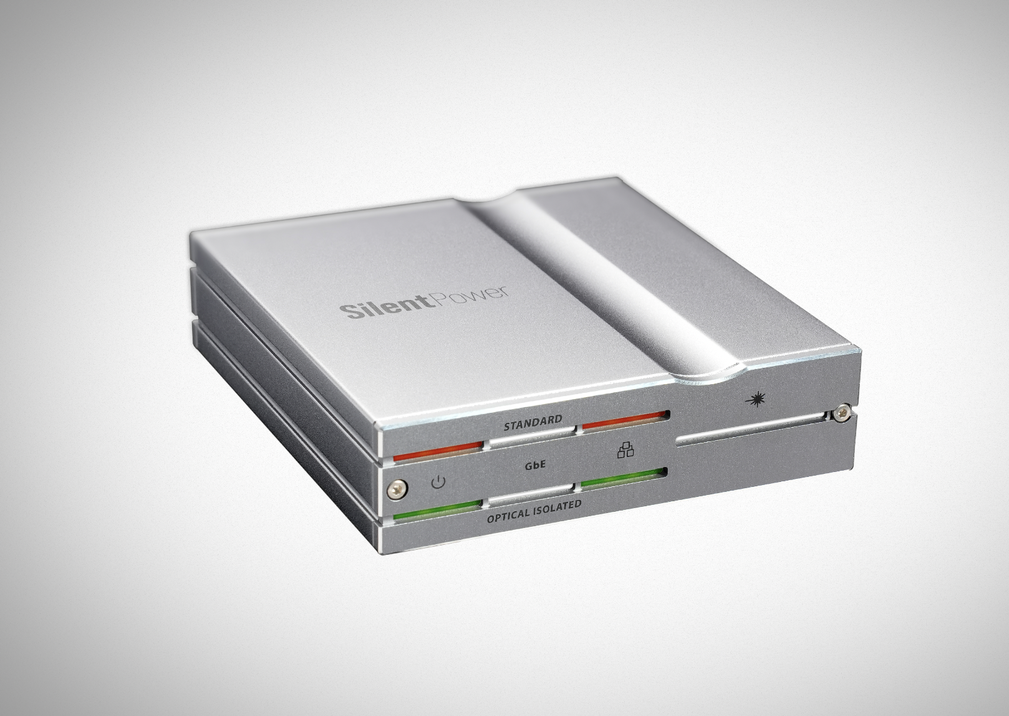
The LAN iPurifier Pro offers a simple plug-and-play solution to what traditionally requires complex steps. Utilising advanced optical galvanic isolation technology, it converts incoming LAN signals into optical (light) signals and back again, ensuring complete electrical isolation between input and output. This prevents any noise from the LAN system from contaminating the stream or DAC.
The LAN iPurifier Pro is an active device that also improves musical timing thanks to its signal regeneration capabilities. This eliminates all jitters and errors so listeners experience the music as clearly and correctly as possible.
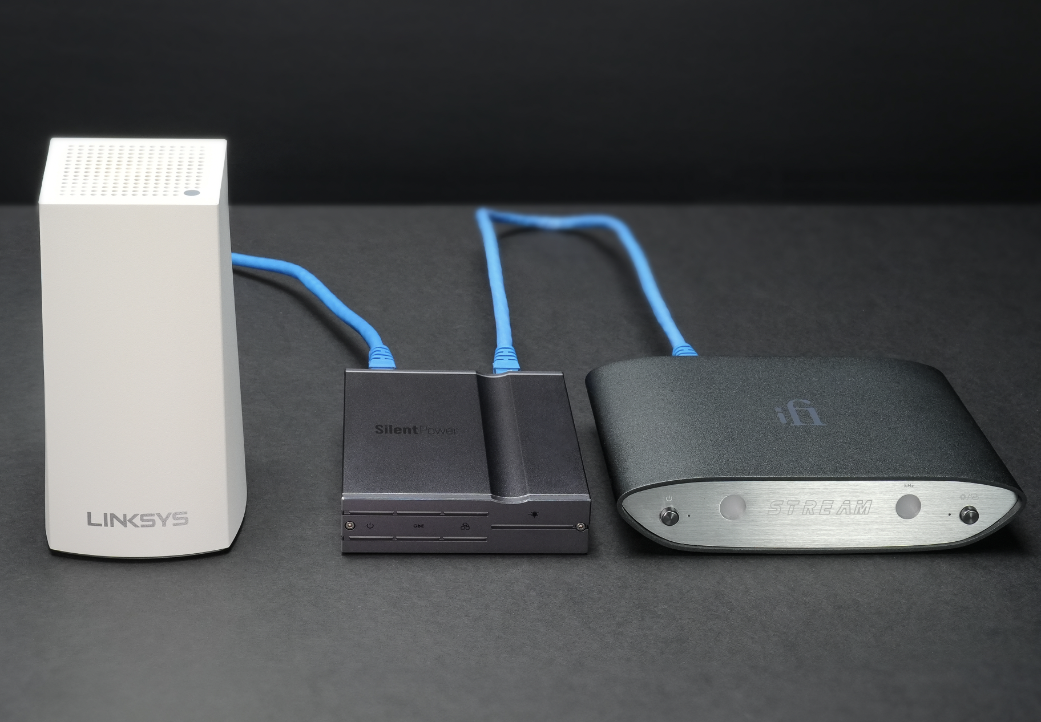
Designed for speed without compromise, the LAN iPurifier Pro ensures transparent data transmission while meeting network connection standards, including 1000BASE-T (Gigabit Ethernet), IEEE 802.3x standard, and supporting 1000/100/10Mbps. It is compatible with a wide range of network devices such as 4K media boxes and media streaming PCs.

SilentPower Products
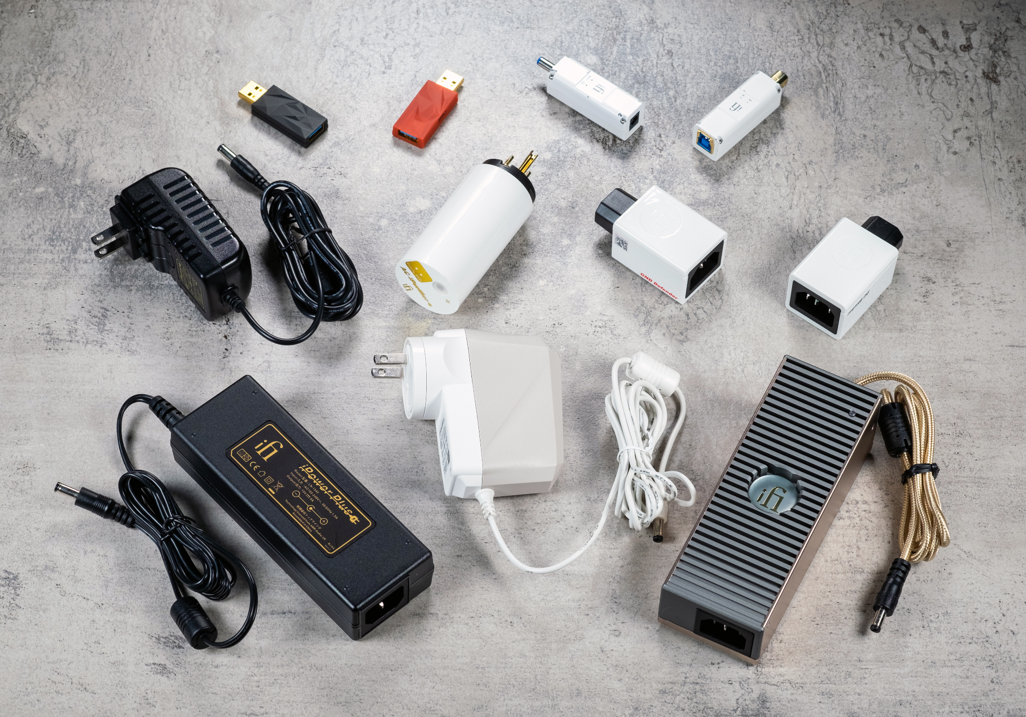
Power Solutions
SilentPower’s iPower series power supplies use proprietary Active Noise Cancellation technology for noise-free performance. delivering clean power to your Hi-Fi system. This actively detects and cancels out incoming noise by generating an inverse signal, ensuring noise-free performance. Together, these technologies deliver exceptionally clean power to your Hi-Fi system, enhancing overall audio performance and fidelity.
Cables
The SilentPower Supa variants boast ANC (Active Noise Cancellation) technology, effectively eliminating unwanted noise and ensuring pure electricity flows uninterrupted. In contrast, the Nova and Quasar do not incorporate ANC capabilities. Additionally, all four power cables are meticulously structured in a geometrically balanced configuration, enhancing the overall dielectric performance of the cables.
A key element in the SilentPower cables is called Ground Zero, an innovation developed in-house at iFi. This technology carries opposite current as well as a fully balanced configuration inside the ground wire to cancel out the magnetic field. This balanced design achieves constant impedance regardless of the position of the cable.
Conditioners
SilentPower conditioners, including the iPurifier series, eliminate noise and jitter from computers, networks, and digital connections. These enhancers ensure optimal audio quality by reducing timing errors and rebalancing digital signals for bit-perfect data transmission, leading to better analog signal conversion.
Accessories
SilentPower accessories include the DC Blocker, DC Blocker+, GND Defender, Groundhog, iEMatch, and headphone adapters. These accessories are designed to eliminate disturbances and deliver clean power to your Hi-Fi system.
- DC Blocker: Eliminates persistent mechanical hum in large amplifiers caused by DC voltage in the mains. It blocks unwanted DC power from interfering with your equipment when plugged into the IEC inlet.
- DC Blocker+: Designed for high power equipment requiring up to 10 Amps, it prevents unwanted DC power on your AC mains supply from causing hum in your amplifier.
- GND Defender: Breaks unwanted ground loops, preventing low-frequency hum while retaining EMI shielding and surge protection. It maintains safety standards by preserving the ground connection.
- iEMatch: Provides ultra (-24dB) and high gain (-12dB) sensitivity adjustment for headphones and IEMs, improving sound quality, dynamic range, and clarity while reducing background hiss.
SilentPower Technology
Active Noise-Cancelling
SilentPower’s market-leading noise-cancelling technology leverages AMR's advanced OptiMains technology, developed two decades ago, to isolate power supplies from grid noise and DC offset, ensuring unmatched power purity in SilentPower products. SilentPower pioneers world-first, patented multi-loop noise elimination technologies, establishing the iFi Audio brand at the industry's forefront. Additionally, inspired by military radar cancellation techniques, iFi's patented Active Noise Cancellation (ANC) ensures power supplies are ten times quieter than most audiophile power solutions.
Active Filtration
SilentPower’s active Noise Cancellation II technology starts noise reduction at 10kHz and is more effective across a wider frequency range compared to passive solutions, ensuring pure signal transmission throughout the SilentPower product range.
Galvanic isolation technology achieves the separation of electrical circuits, effectively eliminating stray currents. Audio signals can pass between galvanically isolated circuits to block differences in ground potential or currents induced by AC power.
Pricing & Availability
The Silent Power range is available to purchase from ifi-audio.com and selected retailers. LAN iPurifier Pro: £299, $299, $AUD299.
For more information about SilentPower and to explore our product range, visit our website at www.ifi-audio.com.

US Press contact:
Shelby Coppola
Hummingbird Media
Public Relations
shelby@hummigbirdmedia.com

About iFi

iFi is the sister-brand of Abbingdon Music Research (AMR) and is headquartered in Southport, UK. The two brands respectively design and manufacture portable, desktop and lifestyle audio products and high-end hi-fi components. Combined in-house hardware and software development teams and a ‘music first’ approach enable iFi and AMR to create advanced audio products that deliver new levels of design, functionality and performance at their respective price points. Since iFi’s formation in 2012, its products have earned many awards around the world, helping it to become one of the fastest-growing brands in its field.

www.ifi-audio.com

LAN iPurifier Pro - General Specification
